Assignment 3

- Write a Python function to find the maximum of three numbers.
num1 =int(input("enter the first number"))
num2 =int(input("enter the second number"))
num3 =int(input("enter the third number"))
if num1 >num2 and num1 >num3:
print("the", num1, " is greater than the", num2, "and",num3)
elif num2 >num1 and num2 >num3:
print("the", num2, " is greater than the", num1, "and",num3)
elif num3 >num1 and num3 >num2:
print("the", num3, " is greater than the", num1, "and",num2)
else:
print("The 3 numbers are equal")

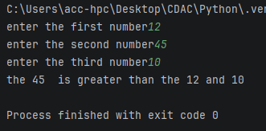
- Create a function that takes a list of numbers and returns their sum.
def sum_lst(lst):
sum=0
for i in lst:
sum+=i
print("The sum of numbers in list is :",sum)

lst=[1,2,3,4,5,6]
sum_lst(lst)

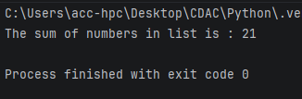
- Write a function with a default argument that prints a greeting.
def greet(name="Python"):
print(f"Hello, {name}!")
greet()

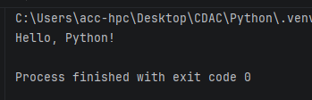

- Write a function is_palindrome() that takes a string as an argument and returns True if the string is a palindrome (reads the same forward and backward) and False otherwise
def is_palindrome(str):
if str == str[::-1]:
return True
else:
return False
str=input("Enter the string : ")
print(is_palindrome(str))

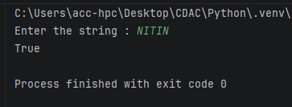
- Write a function count_case() that accepts a string and returns a dictionary containing the count of uppercase and lowercase letters
def count_case(text):
counts = {"uppercase": 0, "lowercase": 0}
for char in text:
if char.isupper():
counts["uppercase"] += 1
elif char.islower():
counts["lowercase"] += 1
return counts

print(count_case("Count of Uppercase and Lowercase"))

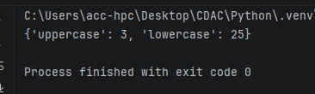
- Write a function unique_list() that takes a list and returns a new list with distinct elements from the first list.
def unique_list(list1):
print("The original list is ",list1)
new_list = list(set(list1 ))
print(" new list with distinct elements from the first list:",new_list)

list1 = [20, 10,20,32,20]
unique_list(list1)

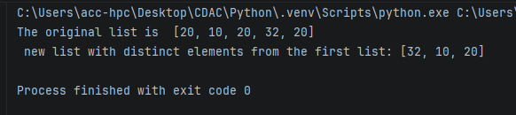

Assignment 4
- Given the string s = "Python Programming", write code to:
o Print the first character.
o Print the character at index 7.
o Print a slice from index 2 up to (but not including) index 8.
o Print a slice from the beginning up to index 5.
o Print a slice from index 6 to the end.
o Print the last character using negative indexing.
def string_operations(s):
# Print the first character
print("The first character is: ", s[0])

#Print the character at index 7
print("the character at index 7:",s[7:8])

#Print a slice from index 2 up to (but not including) index 8.
print("string slicing from index 2 to 8:",s[2:8])

#Print a slice from the beginning up to index 5.
print("slice from the beginning up to index 5 is :",s[0:5])

#Print a slice from index 6 to the end.
print("slice from index 6 to the end is :",s[6:])

#Print the last character using negative indexing.
print("last character using negative indexing is :",s[-1])

s = "Python Programming"
string_operations(s)

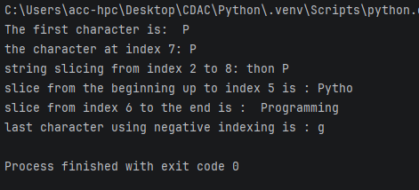
- Given original_string = "Hello", demonstrate how to "update" this string to Goodbye by creating a new string and assigning it to the same variable.
original_string = "Hello"
print("the original string is : ",original_string)
rep_str=original_string.replace(original_string, "Goodbye ")
print("the original string after replace is : ",rep_str)

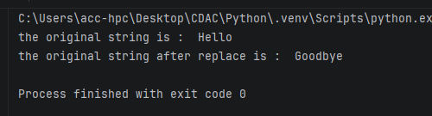
- Write a string that includes a double quote within single quotes, and a single quote within double quotes, using escape characters where necessary.
combined_string = 'He said, "It\'s a beautiful day."'
print(combined_string)

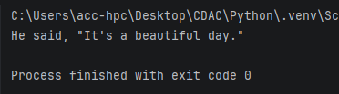
- Demonstrate the use of the + operator for string concatenation.
str1=input("Enter the first string")
str2=input("Enter the second string")
# use of the + operator for string concatenation
concat_str = str1+str2
print("the str after concatenation is : ",concat_str)

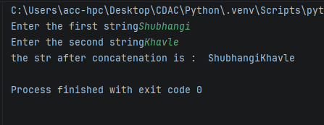
- Demonstrate the use of the * operator for string repetition.
str1=input("Enter the string")
# the use of the * operator for string repetition
str_repetition = str1*4
print("the str after string repetition is : ",str_repetition)

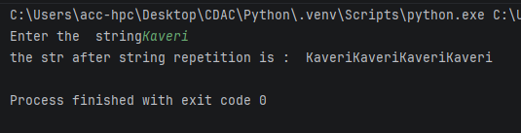
- Use the in operator to check if a substring exists within a larger string.
main_string="Python is fun!"

if "Python" in main_string:
print("Substring found!")
else:
print("Substring not found.")

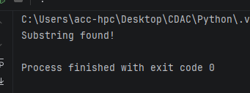
- Use the not in operator to check if a substring does not exist within a larger string.
main_string="Python is fun!"

if "string" not in main_string:
print("Substring not found!")
else:
print("Substring found.")

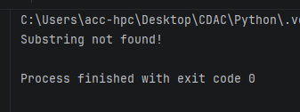
- Given name = "Alice" and age = 30, use the f-string formatting method to create a string that reads: "Alice is 30 years old."
- Given text = " Python is FUN! ", use built-in string methods to:
o Convert the string to all lowercase.
o Convert the string to all uppercase.
o Remove leading and trailing whitespace.
o Replace "FUN" with "amazing".
o Check if the string starts with "Py".
o Check if the string ends with "!".
o Count the occurrences of the letter 'o'.
def str_methods(text):
#Convert the string to all lowercase
print("The text in lowercase is : ",text.lower())

#Convert the string to all uppercase.
print("The text in uppercase is : ", text.upper())

#Remove leading and trailing whitespace
stripped_text = text.strip()
print("The text after Remove leading and trailing whitespace is : ",stripped_text)

#Replace "FUN" with "amazing"
print(text.replace("FUN", "amazing"))

#Check if the string starts with "Py"
print(text.startswith("py"))

#Check if the string ends with "!".
print (text.endswith("!"))

#Count the occurrences of the letter 'o'
print(text.count("o"))

text = " Python is FUN! "
str_methods(text)

